**Running the Engraver**

1. After clicking the Print button on your computer, the printer will display that a job is present.

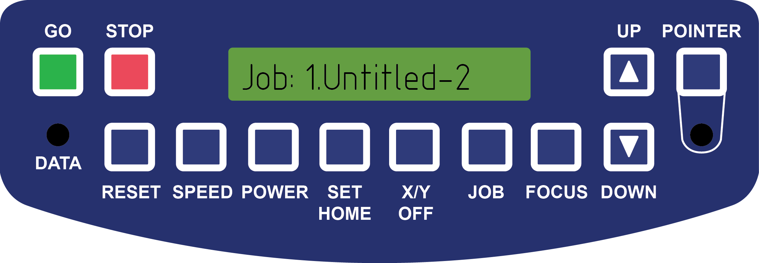

1. First set the home position of your art.
   1. Click the X/Y Off button

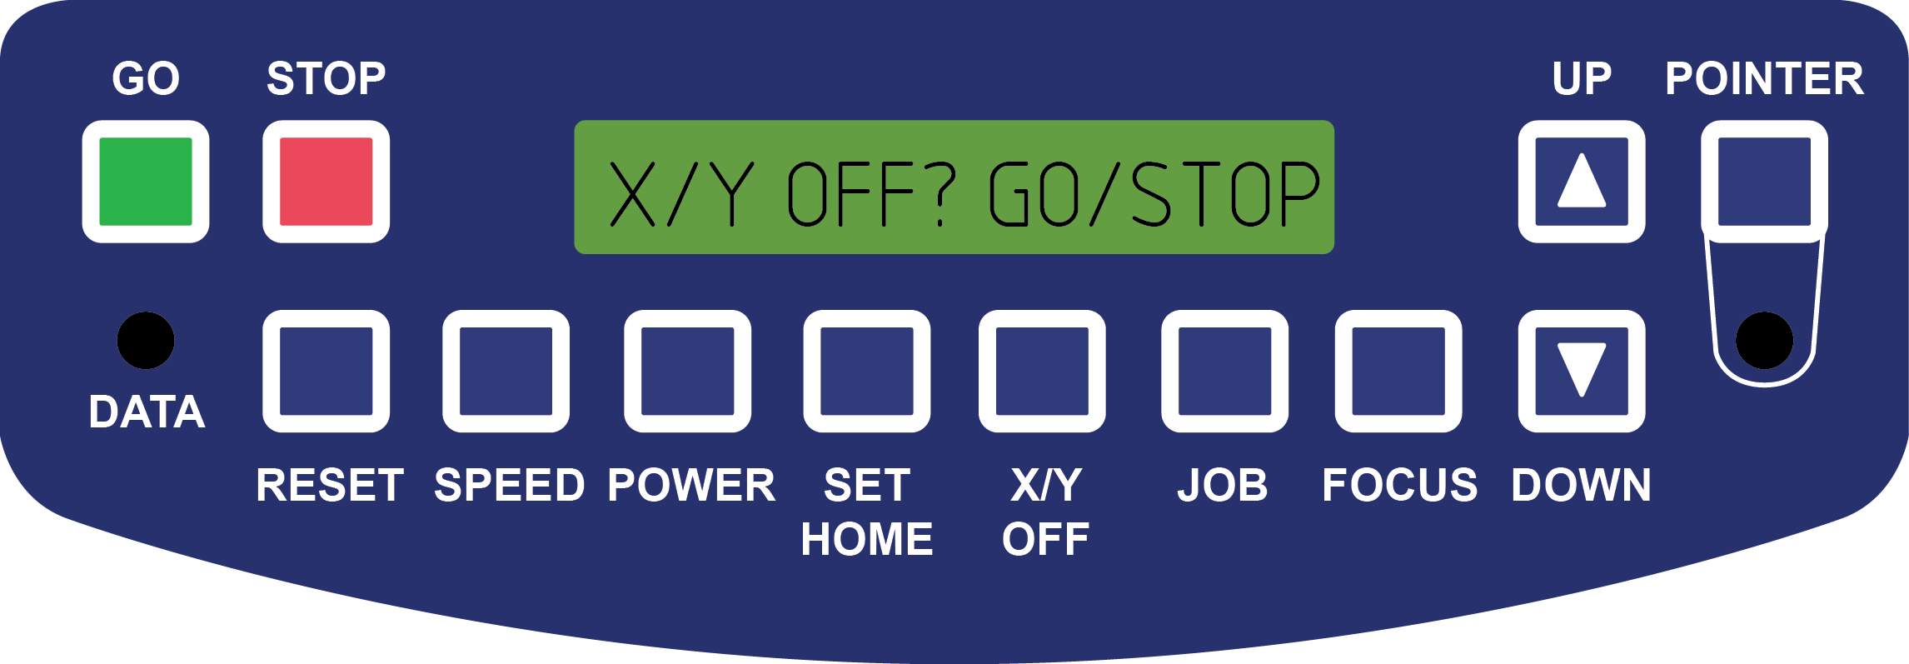

* 1. Click the Go button to confirm that you want to disable the axes. The display will now show the coordinates of the laser in the X and Y direction.

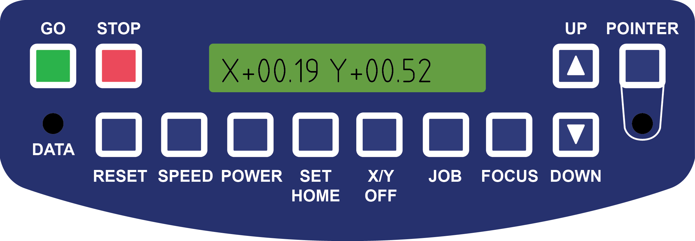

* 1. Click the Pointer button. This will shine a red colored laser onto your work to aid in the position process.

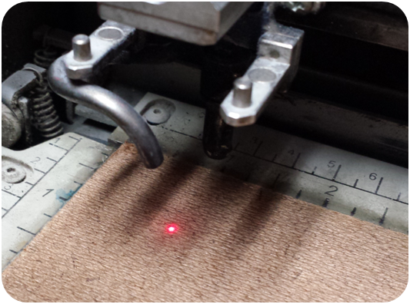

* 1. Once you are happy with the home location, click the Set Home button. The display will confirm that you have set the Home/Center of the work piece.

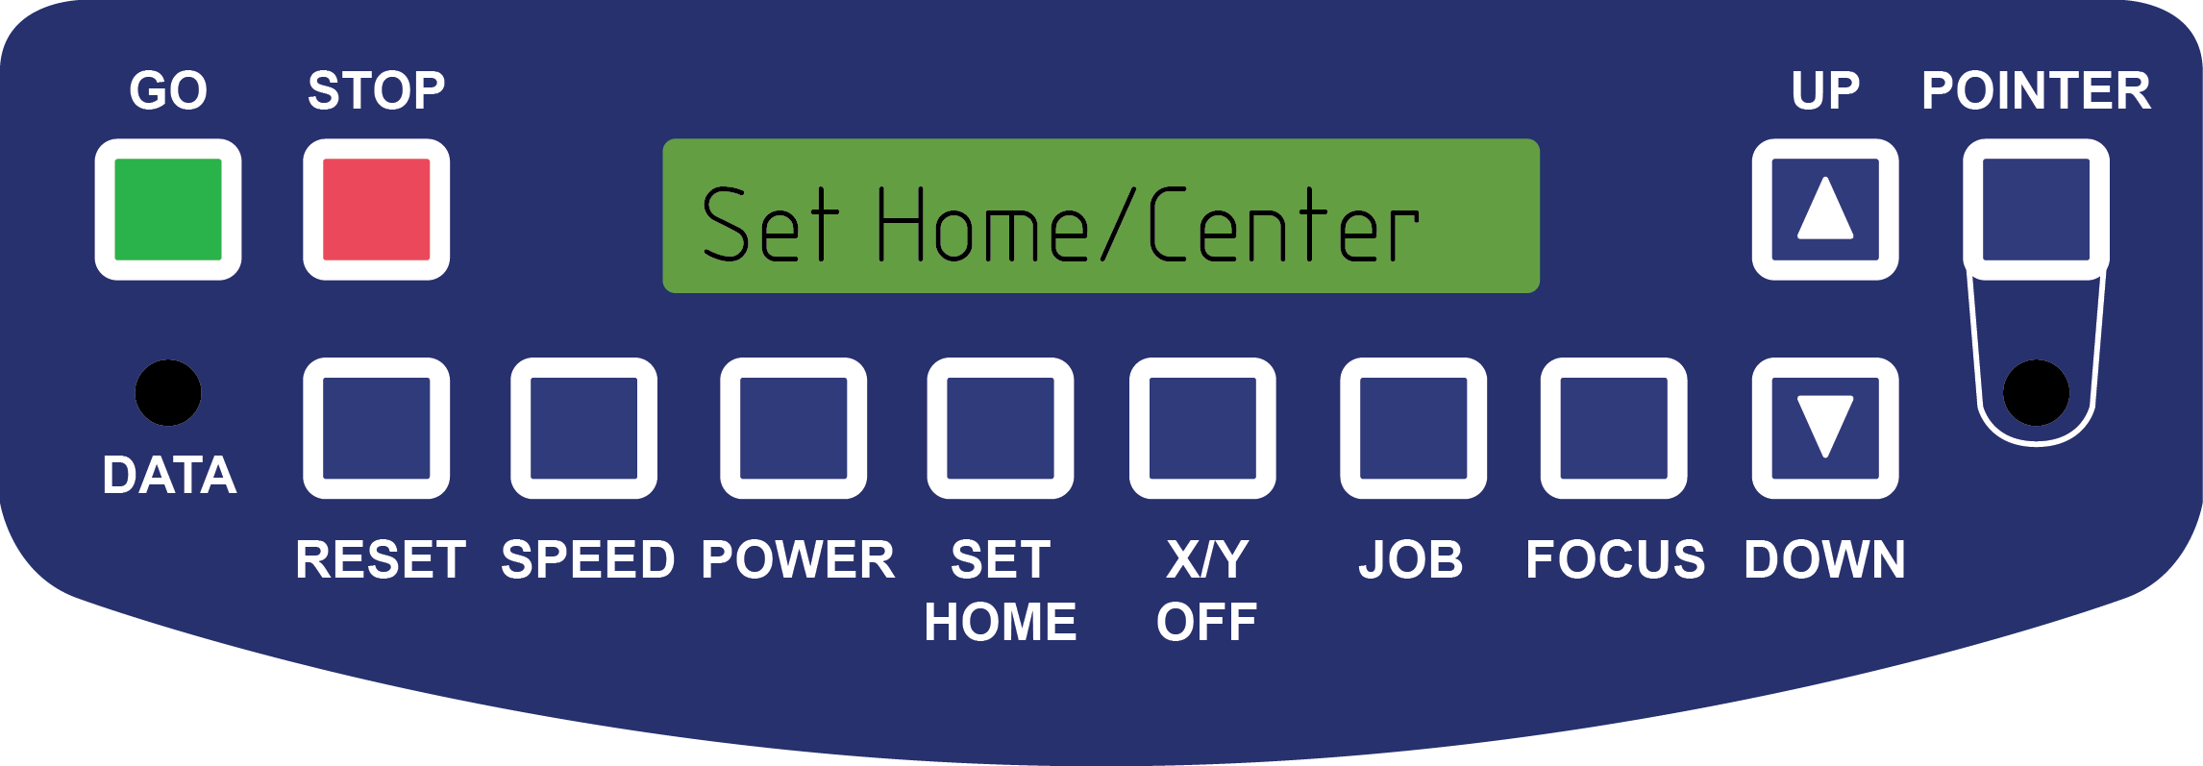

1. Next we’ll set the table height so the laser is properly focused.
   1. Click the Stop button (this prevents the laser from moving away from its home position.
   2. Click the Focus button

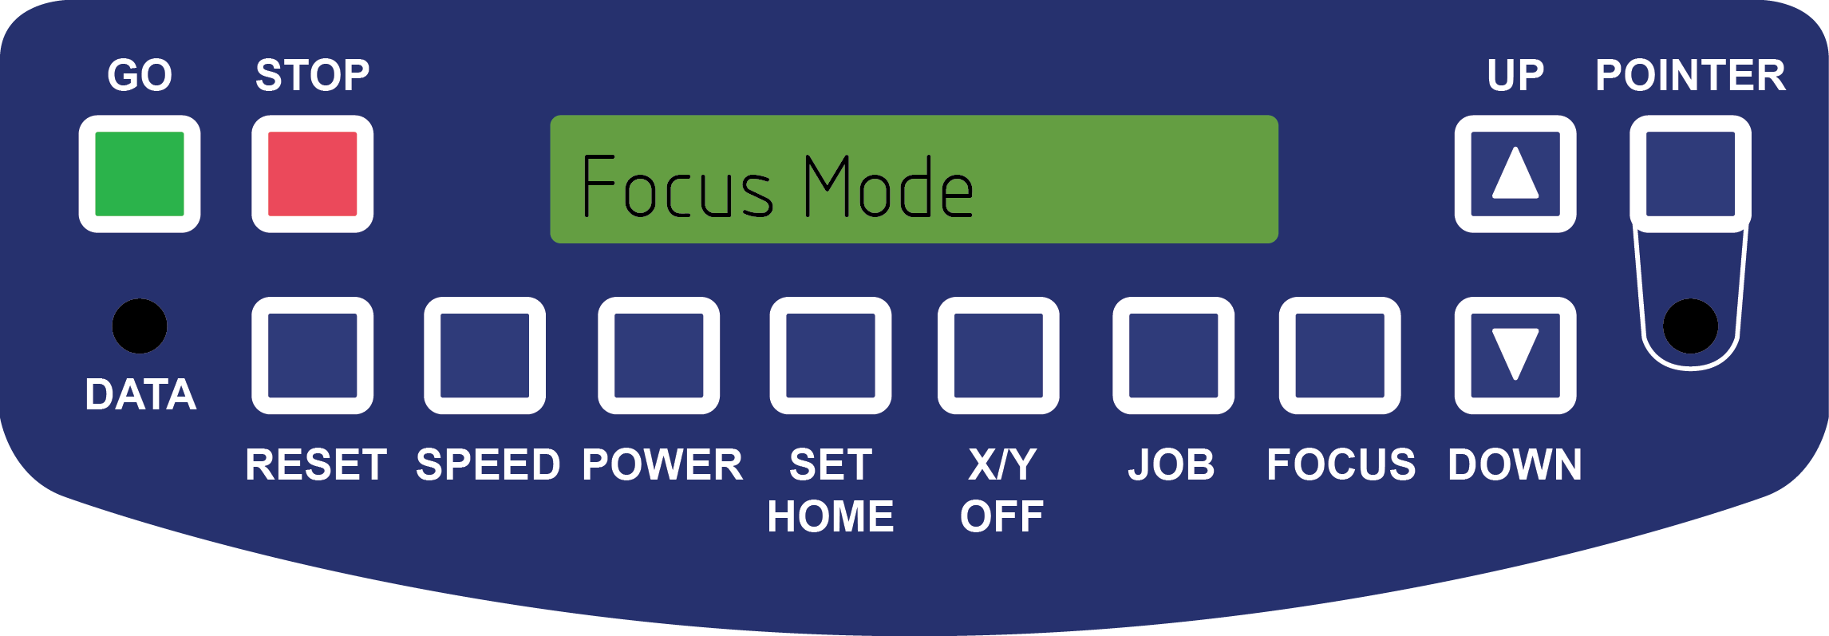

* 1. Put the gage clip onto the laser so that it is seated on its shelf with the dowels protruding through the clip.

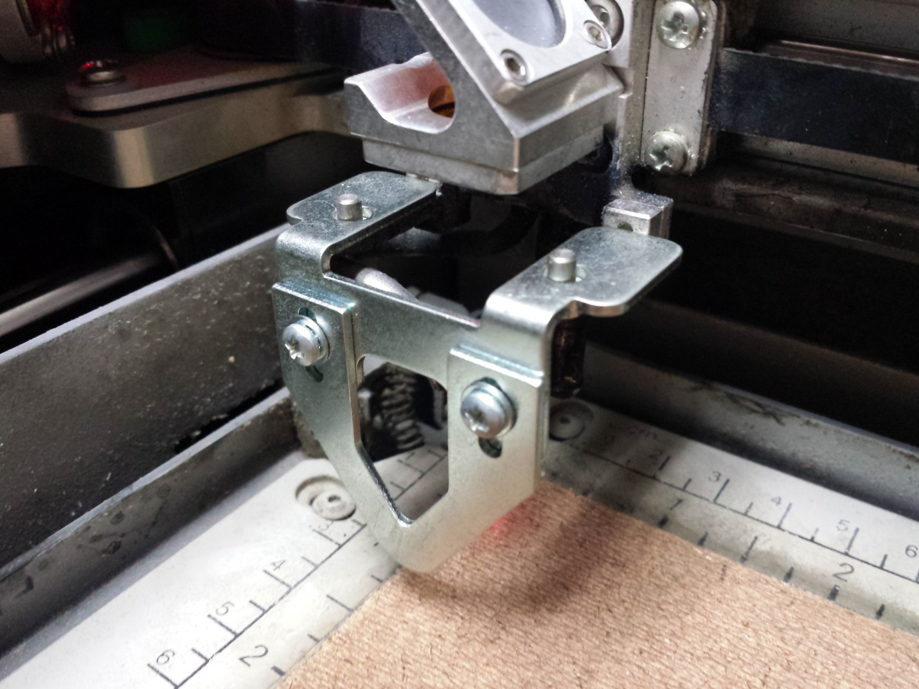

* 1. Raise the table until the gage clip just touches your part.

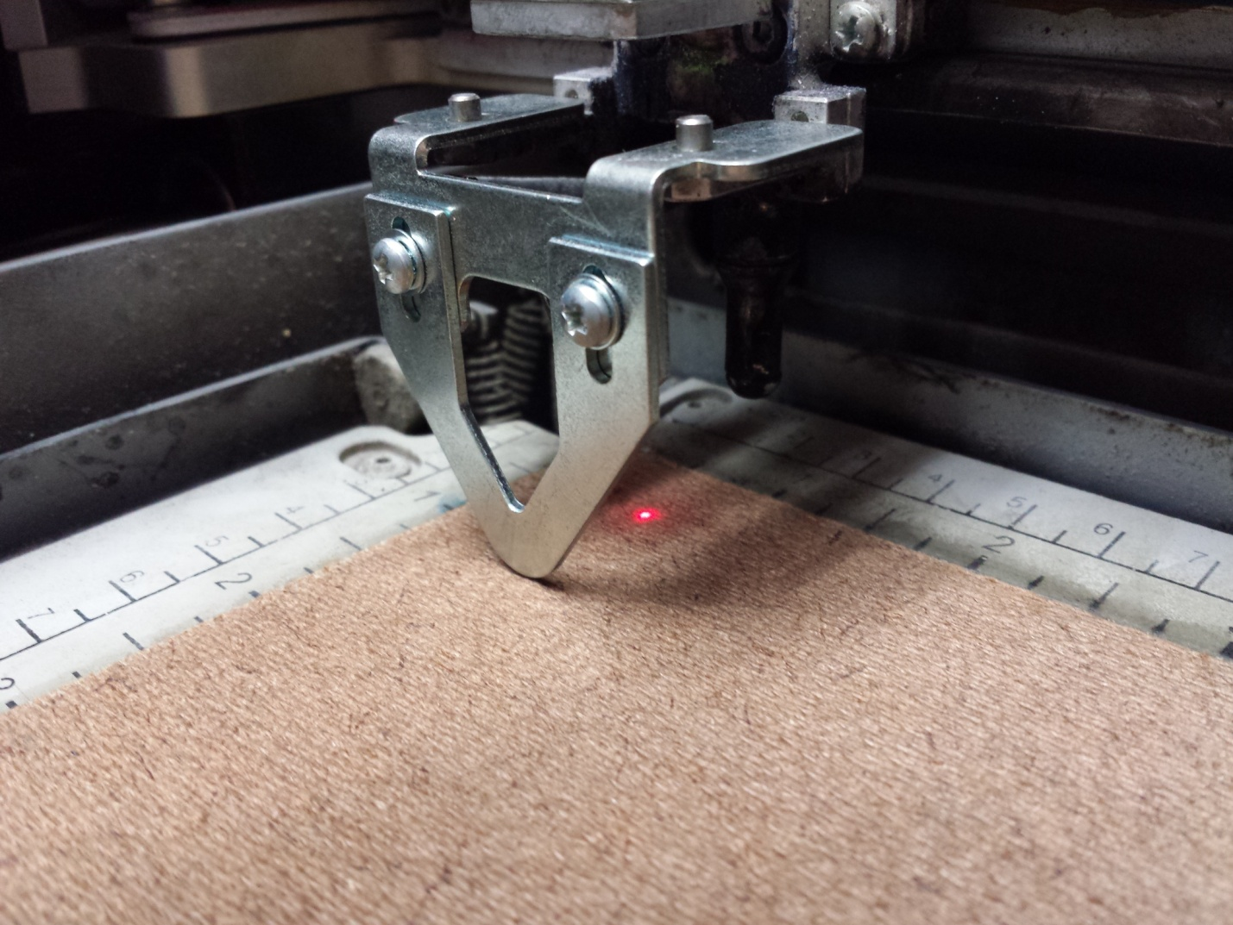

1. Prepare the laser environment by turning on the air and ventilator
   1. To the left of the machine on the wall is an air valve. Turn this so it is aligned with the pipe.

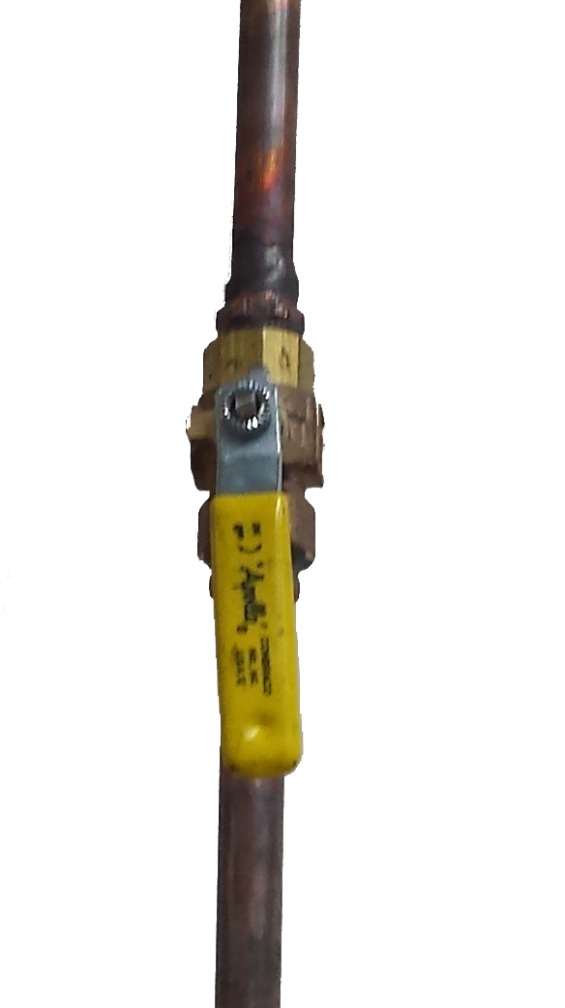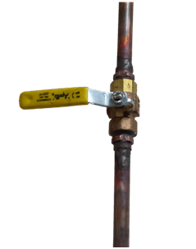

* 1. To the right of the machine is the ventilator. Rotate the knob in a clock-wise direction so the unit turns on (this is at its highest speed).

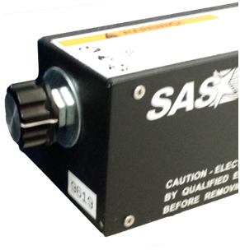

1. Start cutting/engraving
   1. Press the Go button when you are all set. The display will show the user the elapsed time and the resolution of the print.

